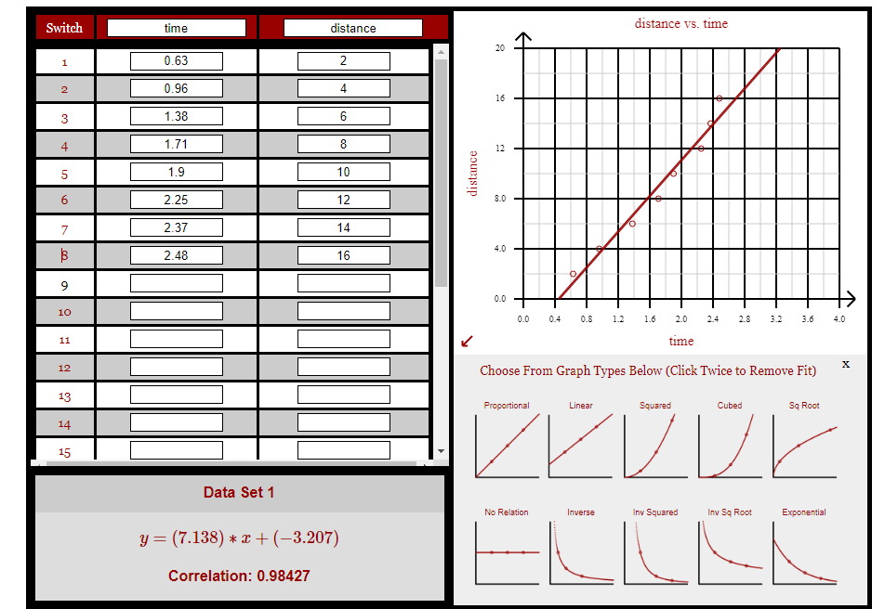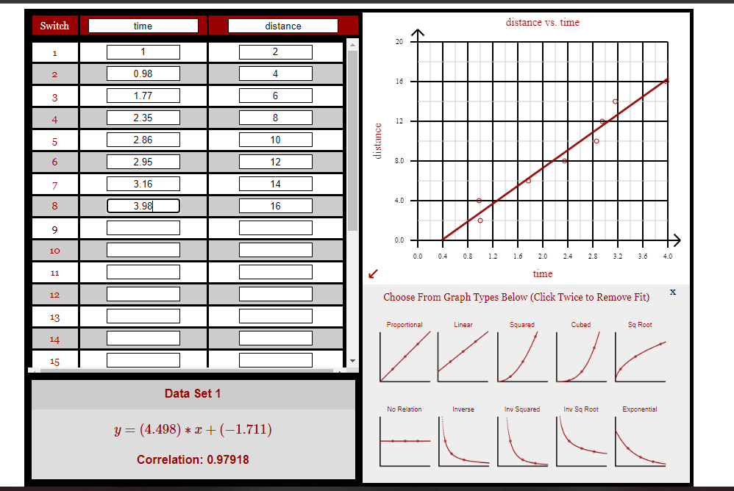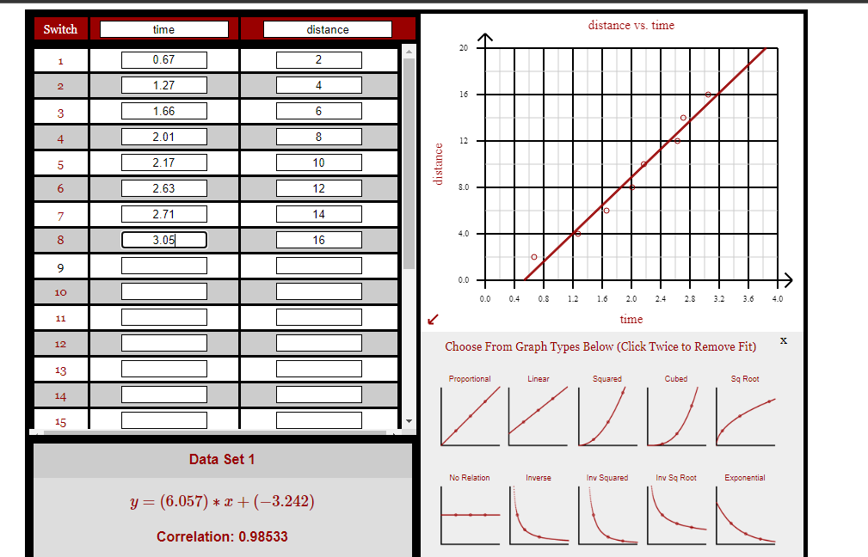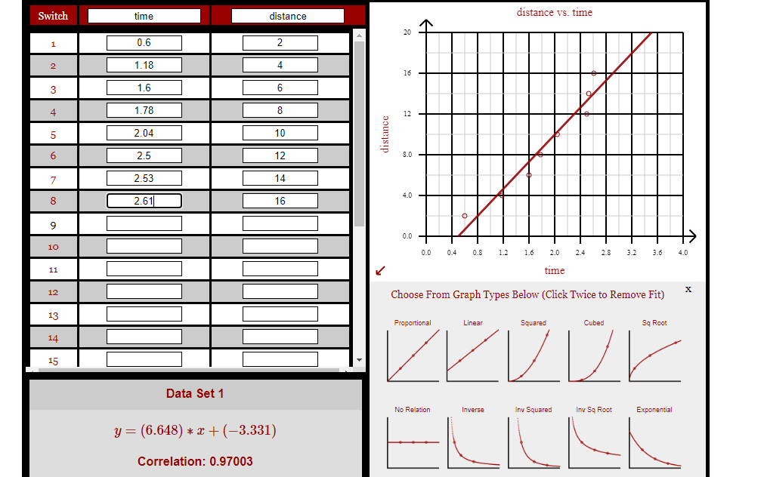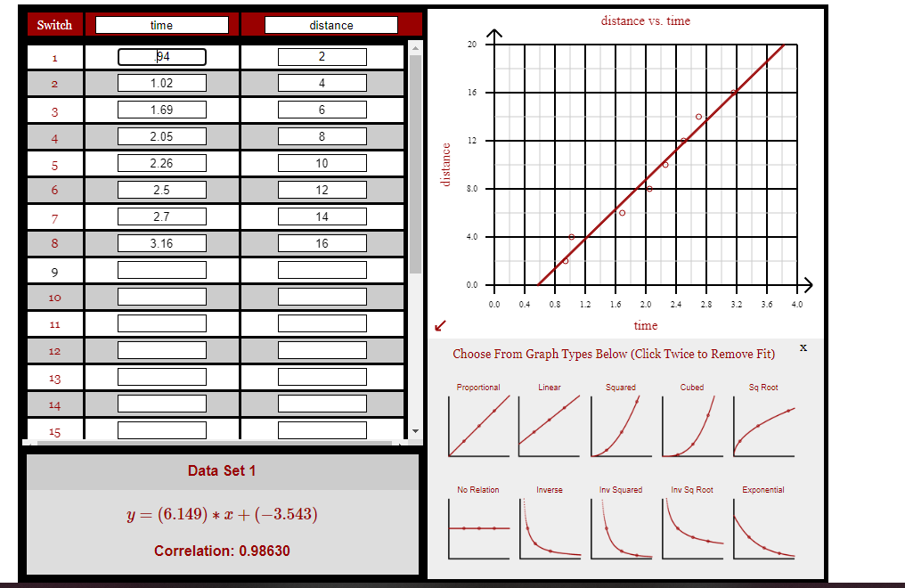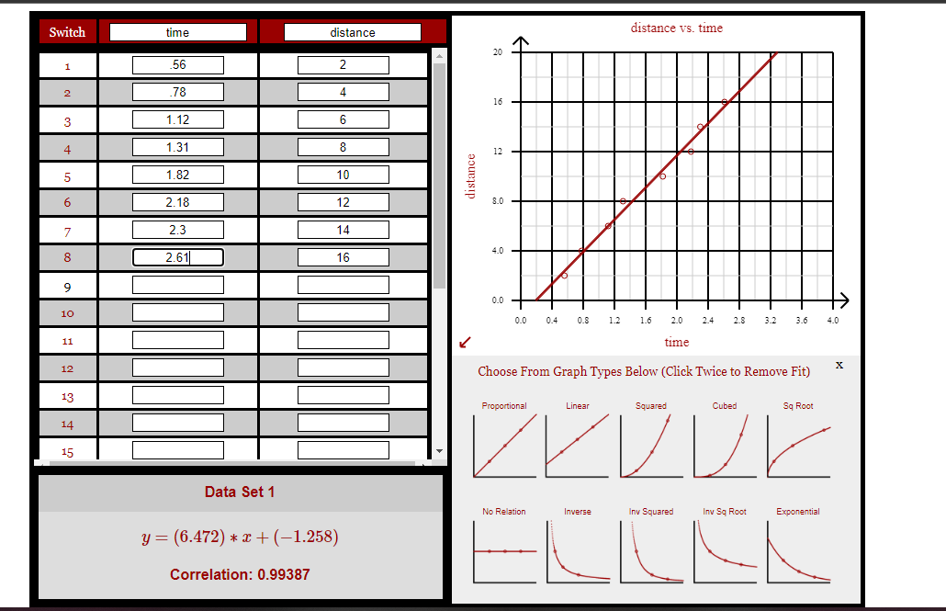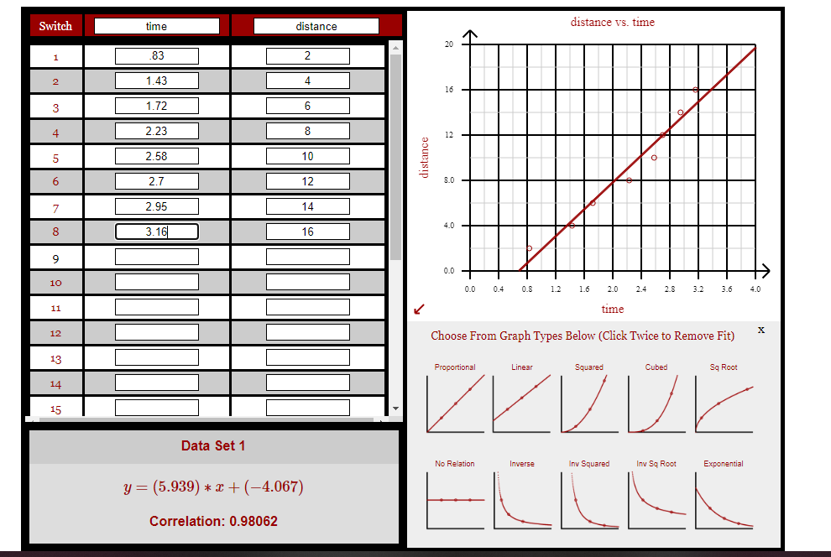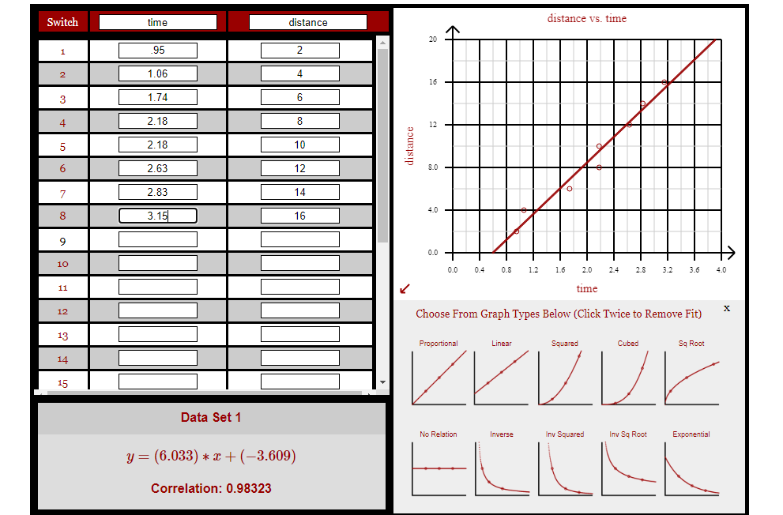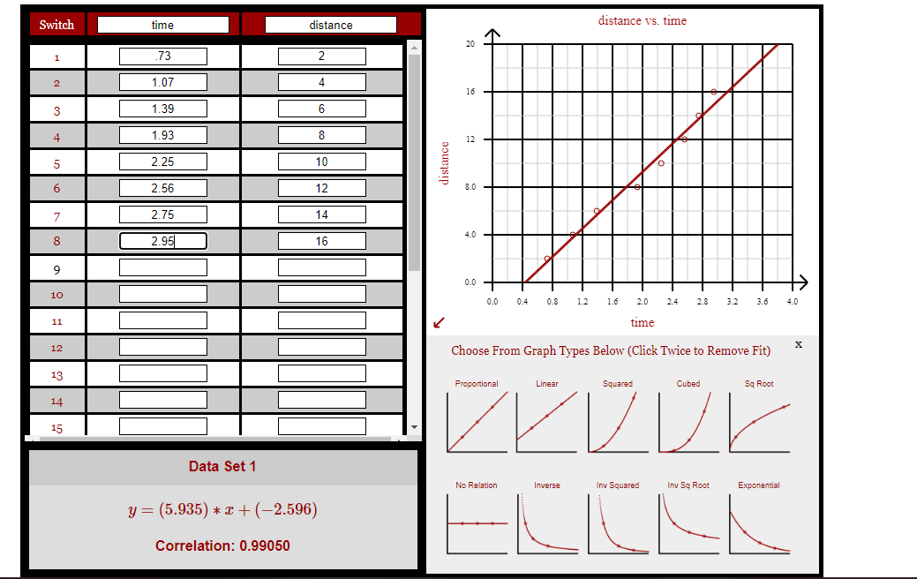

Conclusion:

There are two main sources of error to account for in this lab. The first of many sources of error is human delay. Humans have a delay to their actions. The time it takes for the brain to tell your hand to stop the timer makes a big difference in the time recorded. Another source of error is that the distances marked out by tape was not the exact distance it said it was. This means that it would change the distance we used to find the velocity. This is because the formula used to find velocity is distance divided by time and since the distance is off, then the velocity is off.